Logbook Week 4
February 3, 2026

There was a big flood in ETB!

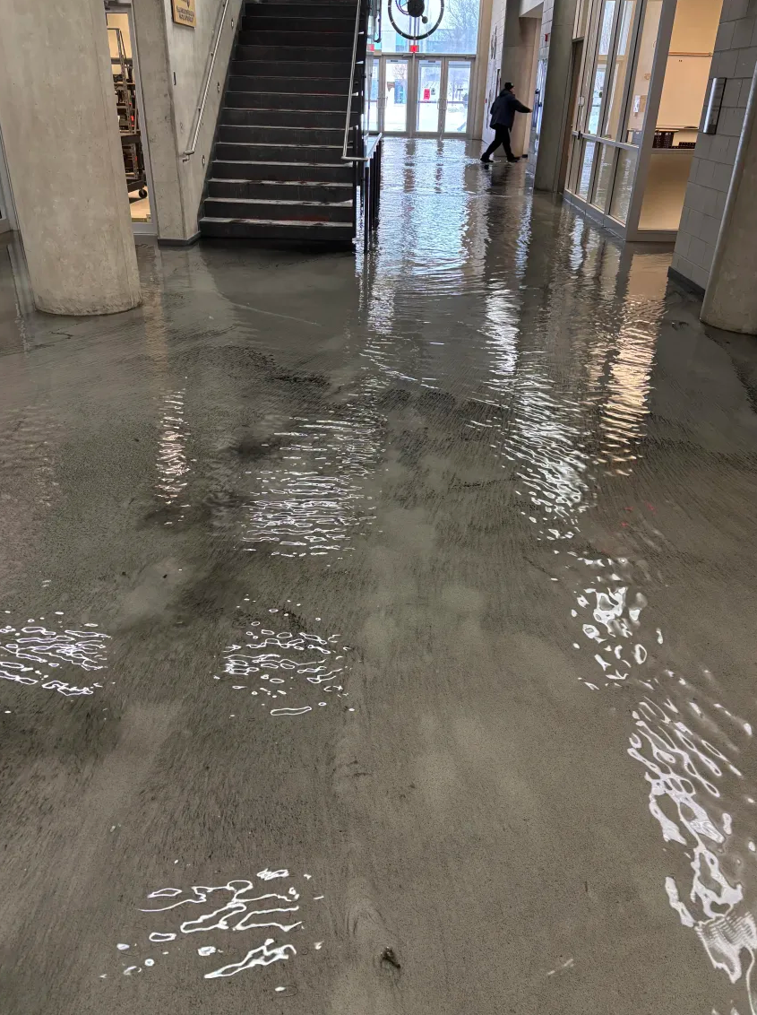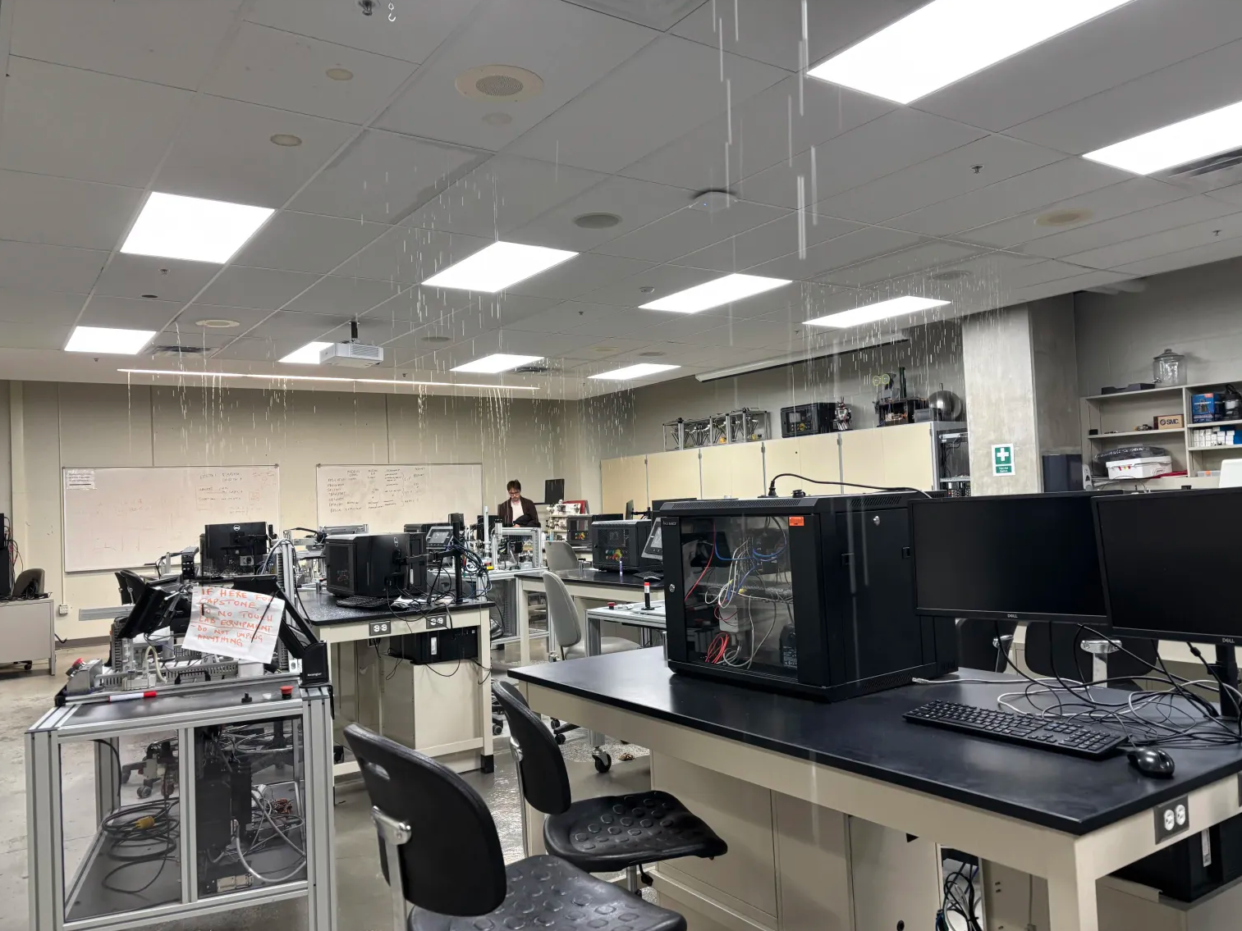

The building closed down for repairs. We went to the library to work instead.

On the fourth week we:
- Worked on the design for the linear slide. We decided to focus on this first as it will be the base for the entire system, and will determine the size of the platform and the other substations. We started a master assembly CAD for it:
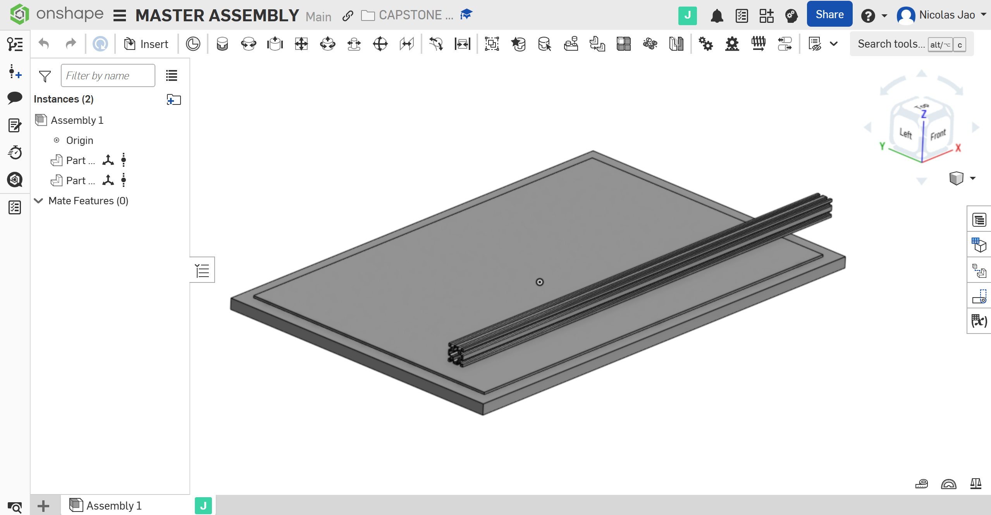
So far, it has the table part and the 4040 Vslot extrusion bar part. We did this for general estimation of dimensions of the linear slide base station. I will need to find the threaded hole dimensions and locations on the table for the CAD so that we can plan mounting things on it. We plan to mount this extrusion bar by putting screws through the other side on the bottom of the table, with nuts in the V slots, then tighten the screws.
- Jamie brought in his 3D printer spare parts. We used them to brainstorm our linear slide design. We chose the 4040 Vslot extrusion bar, a belt drive system for moving the platform, and a stepper motor for the belt drive. We researched that we could get more similar parts at 3D printer repair shops around the GTA if we need them.
- We found the datasheet for the stepper motor for the belt drive and shopped for a motor driver for it. We tested it with the motor driver today. Conclusion: our current one that we already have from our Arduino kits doesn’t work and we will need to come up with a new solution.
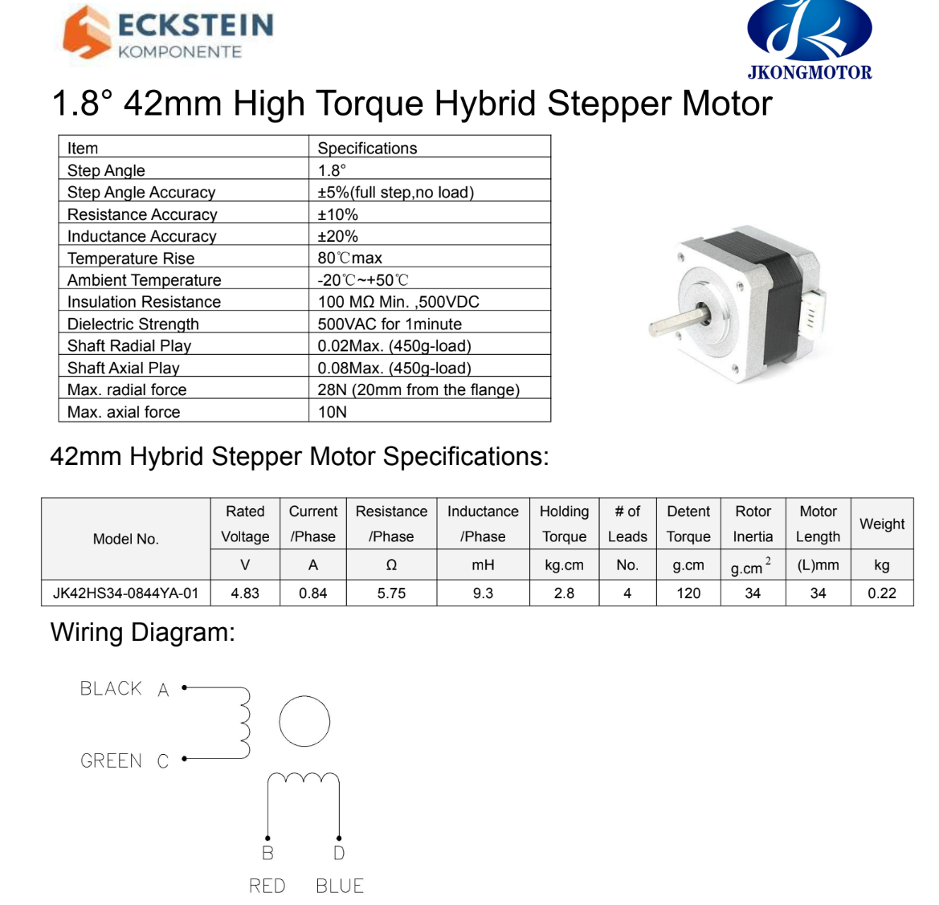

Things we will work on next week:
- Find out the hole thread size of the table we’re building on and the full dimensions of hole spacing (IMPORTANT for CAD progress). Perhaps there is a physical sketch or CAD from whoever made the table?
- Buy a bamboo mat for rolling sushi from a store. We aren’t planning to build anything yet, as we are in the design phase, but getting the bamboo mat that will be on the platform to roll the sushi will be beneficial already as we can plan the dimensions of the platform and ribcage roller around it.
- Find a longer belt for the belt drive. The one we have from Jamie’s 3D printer is less than a metre long. We want our linear slide to be longer than that, so we need a longer belt.
- Jamie will continue perfecting the ribcage roller design
- Jacob will bring home the stepper motors Jamie brought and start testing them with motor drivers
- Jacob wants to start dedicating time to learning how to program our UR robot
- General continuation of work on the CAD design and BOM of substations
- General continuation of work on the motors, controller, and wiring of substations

